|  |  |
| --- | --- |
|  | **AMERICAN INTERNATIONAL UNIVERSITY-BANGLADESH (AIUB)**  Faculty of Engineering  Department of Electrical and Electronic Engineering |

##### ELECTRONIC DEVICES LAB



**\*Rename your pdf file name as: SERIAL_NAME_ID_GR NO_ASSESSMENT NAME & NO.**

**Example: 09_AHMED RAHIM_22-12345-3_GR 03_LAB 01**

**\*Report should be handwritten and PDF in format.**

**\*Topics to be covered: Title >> Objectives >> Theory & Methodology >> Apparatus >> Results & Simulations >> Discussion & Conclusion >> Reference.**

**\*Submit the report before the next lab class in the provided link (check portal notice).**

|  |  |
| --- | --- |
| **SECTION: M** | **SEMESTER: SPRING 23-24** |
| **GROUP NUMBER: 5** | **DATE OF SUBMISSION: 26/03/24** |

**\*Follow the upload rules during submission.**

|  |  |
| --- | --- |
| **SUBMITTED BY** | |
| **NAME: CHINMOY GUHA** | **ID: 22-48056-2** |
| **CLASS SERIAL NUMBER: 14** | **CONTACT: 01706466663** |

|  |
| --- |
| **LAB NO:06**  **TITLE: Study of BJT Biasing Circuit – Fixed Bias and Self-Bias Circuits.** |

|  |  |  |  |
| --- | --- | --- | --- |
| **Class SL** | **Group Member’s Name** | **ID** | **Contact Number** |
| 11 | FERDOUS, AMINA | 22-47822-2 | 01641586846 |
| 12 | UDDIN, MOHAMMAD ANSAR | 22-47975-2 | 01797180123 |
| 13 | TAIEB, ABDULLAH AL | 22-48028-2 | 01642511014 |
| 14 | GUHA, CHINMOY | 22-48056-2 | 01706466663 |
| 15 | CHAKRABORTY, SUVRA | 22-48067-2 | 01996088480 |
|  |  |  |  |
|  |  |  |  |
|  |  |  |  |
|  |  |  |  |
|  |  |  |  |

**SUBMITTED TO:**

**SUJAN HOWLADER (ESSAN), ASSISTANT PROFESSOR**

**DEPARTMENT OF EEE, FACULTY OF ENGINEERING**

***Title and objective:***

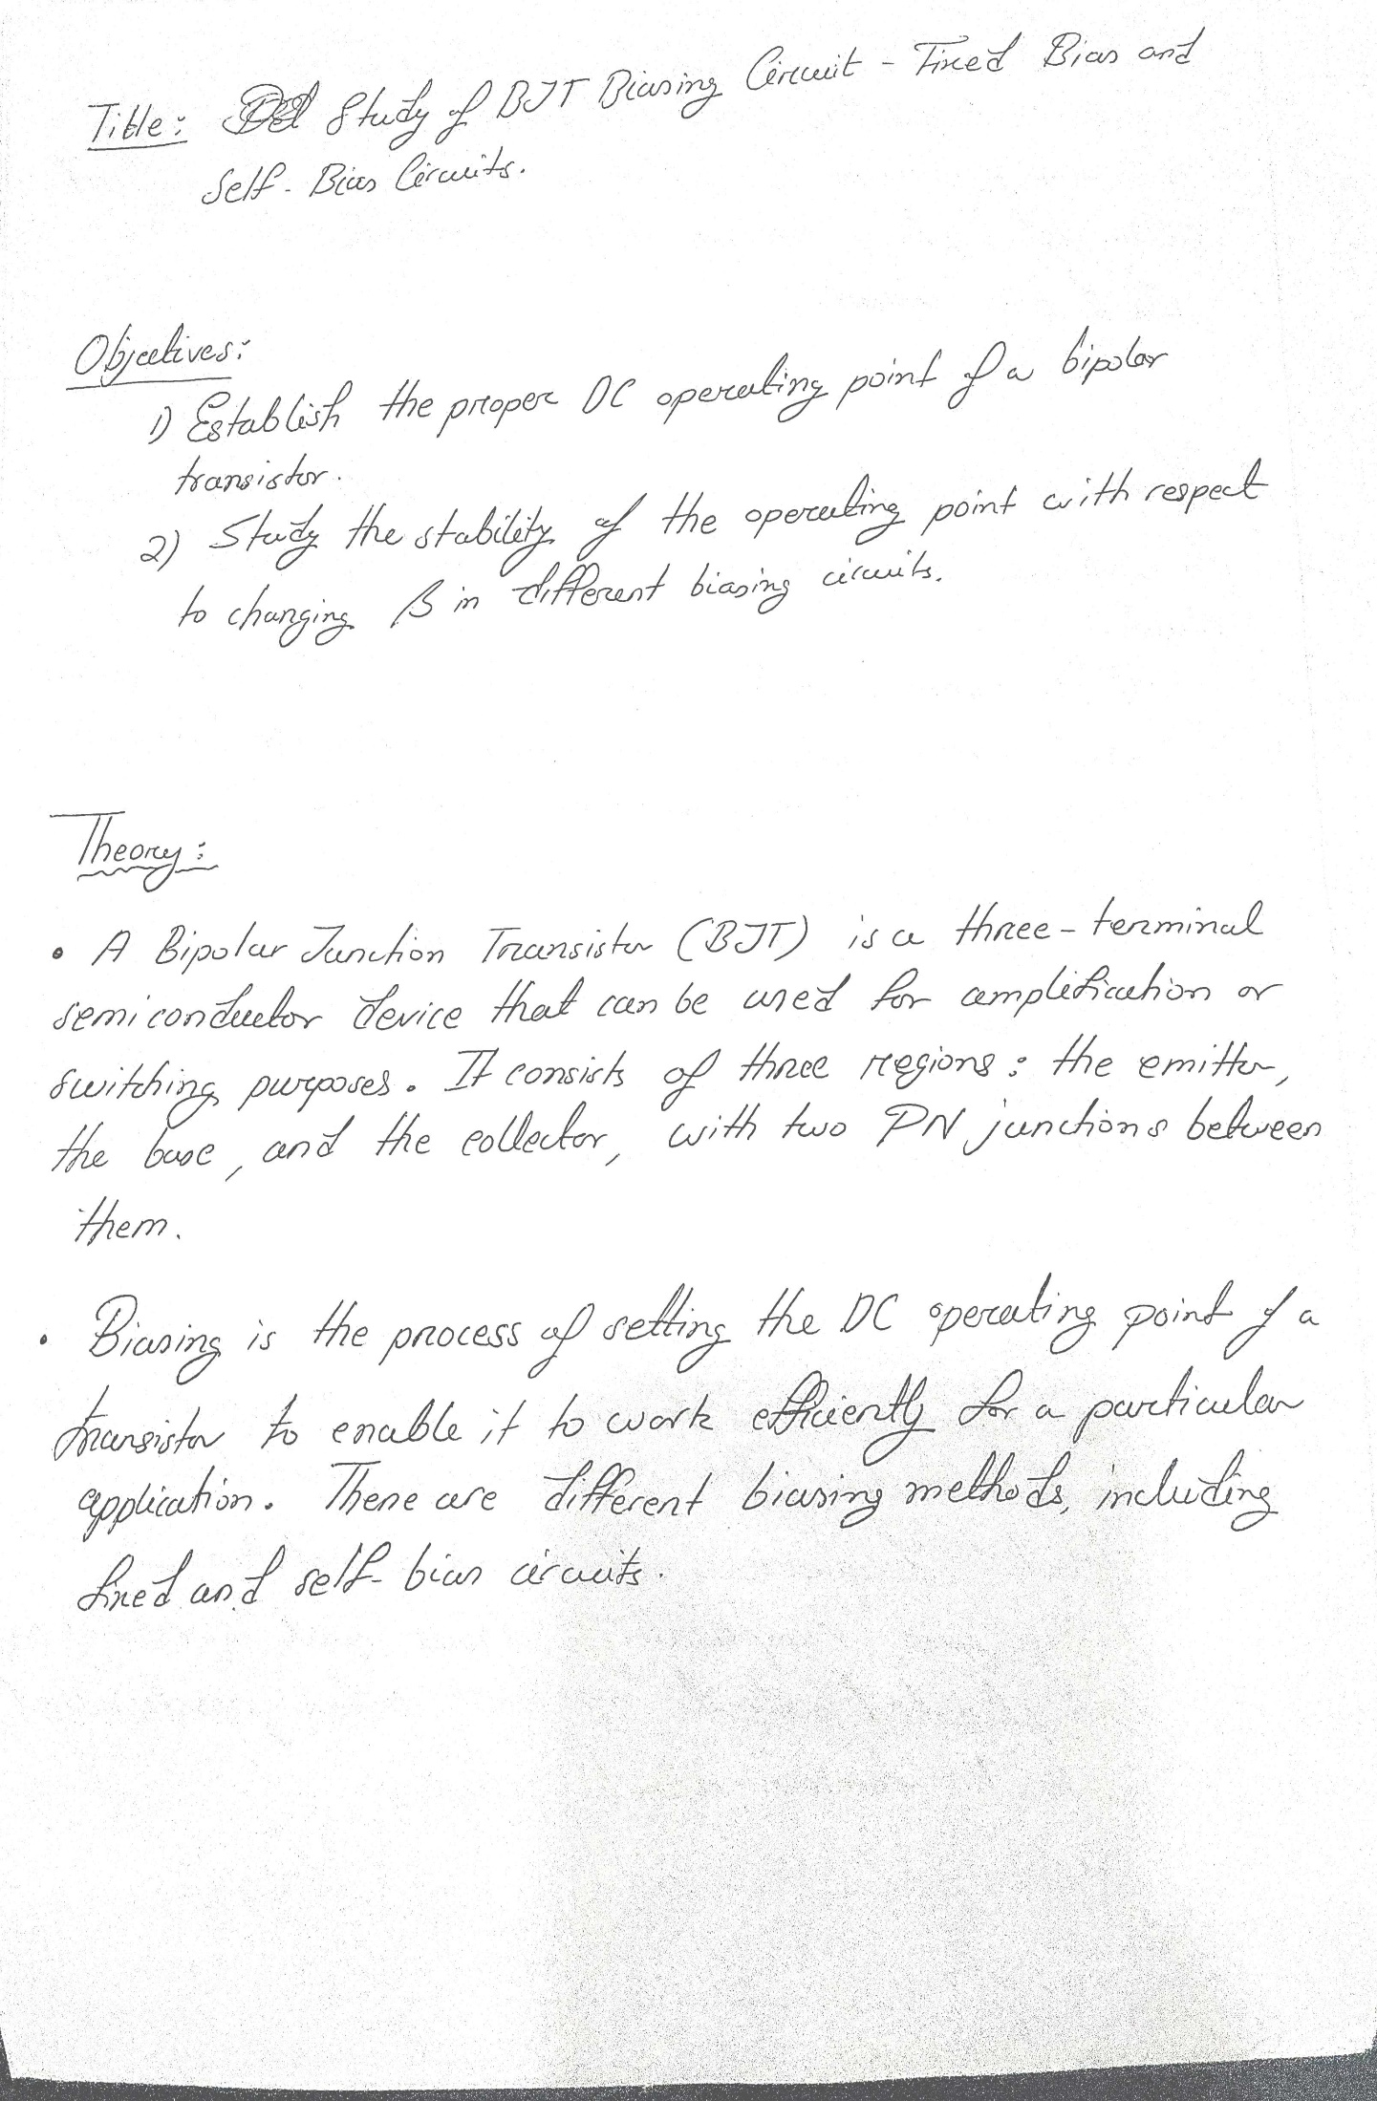

***Theory and Methodology:***

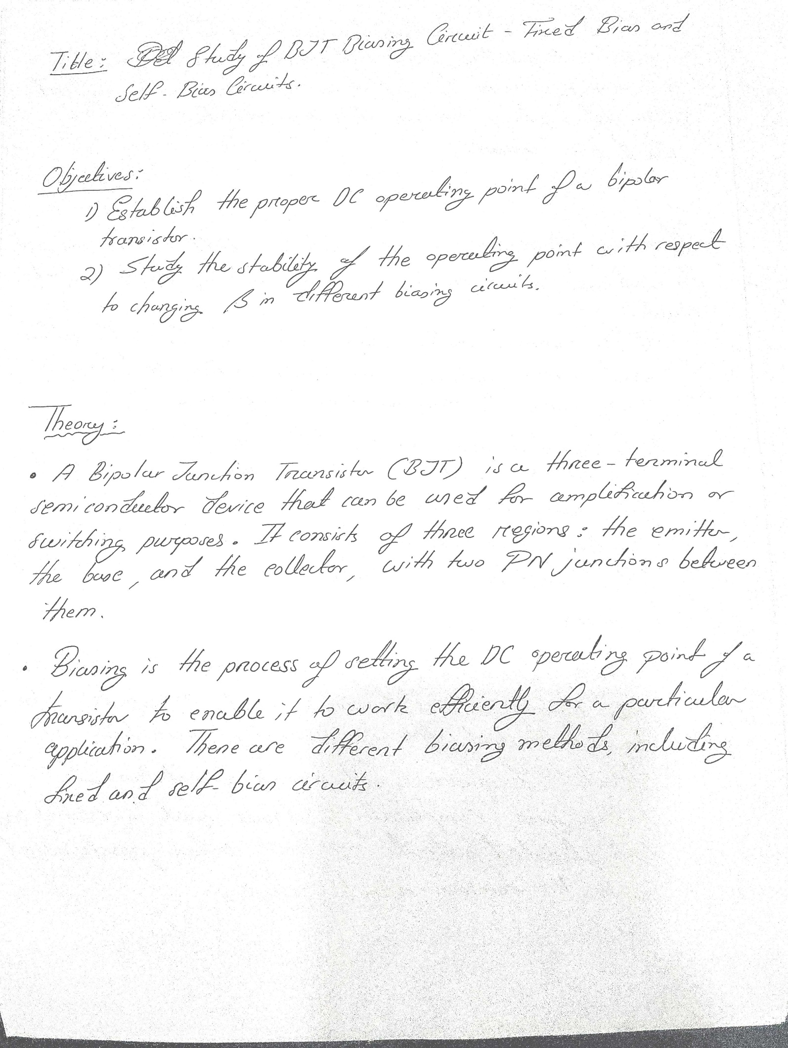

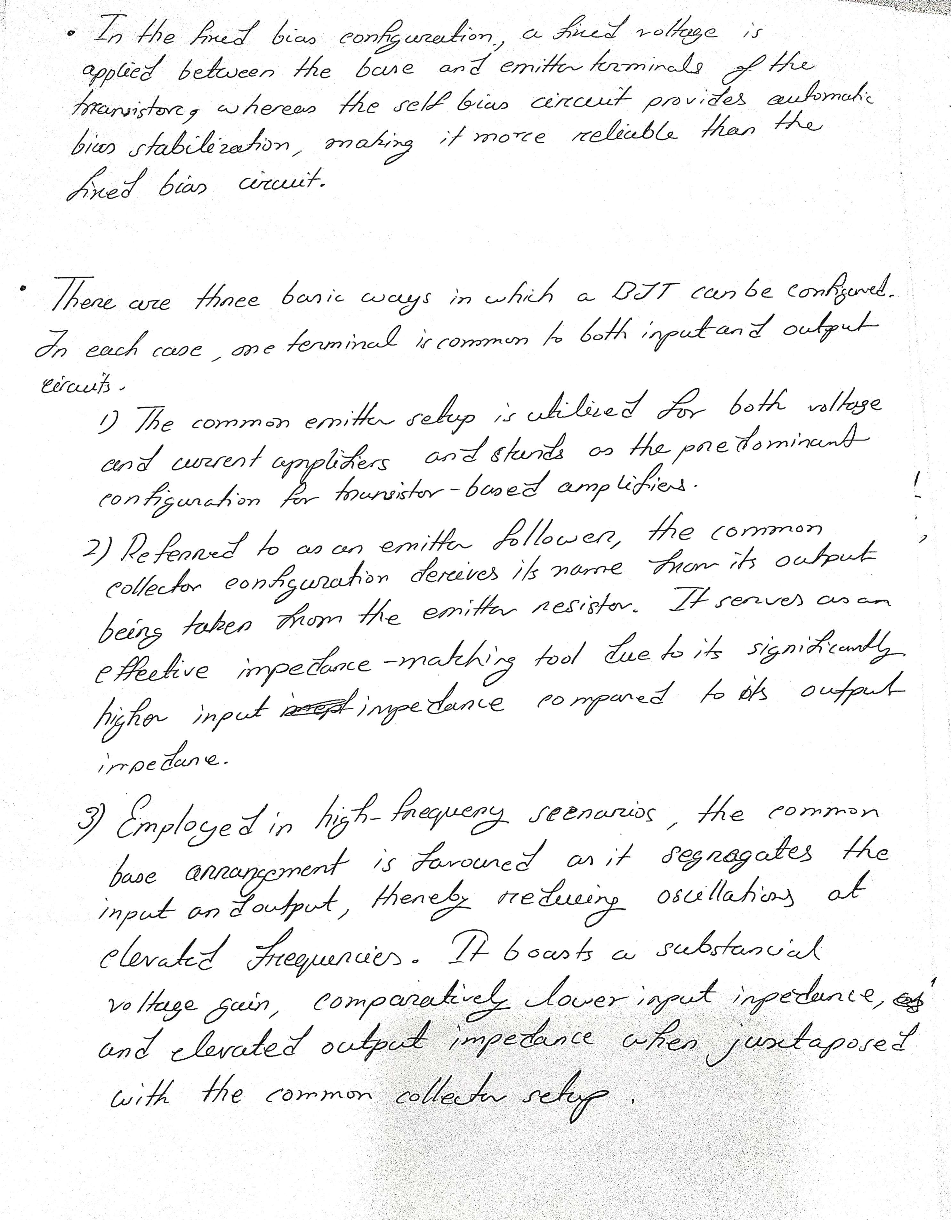



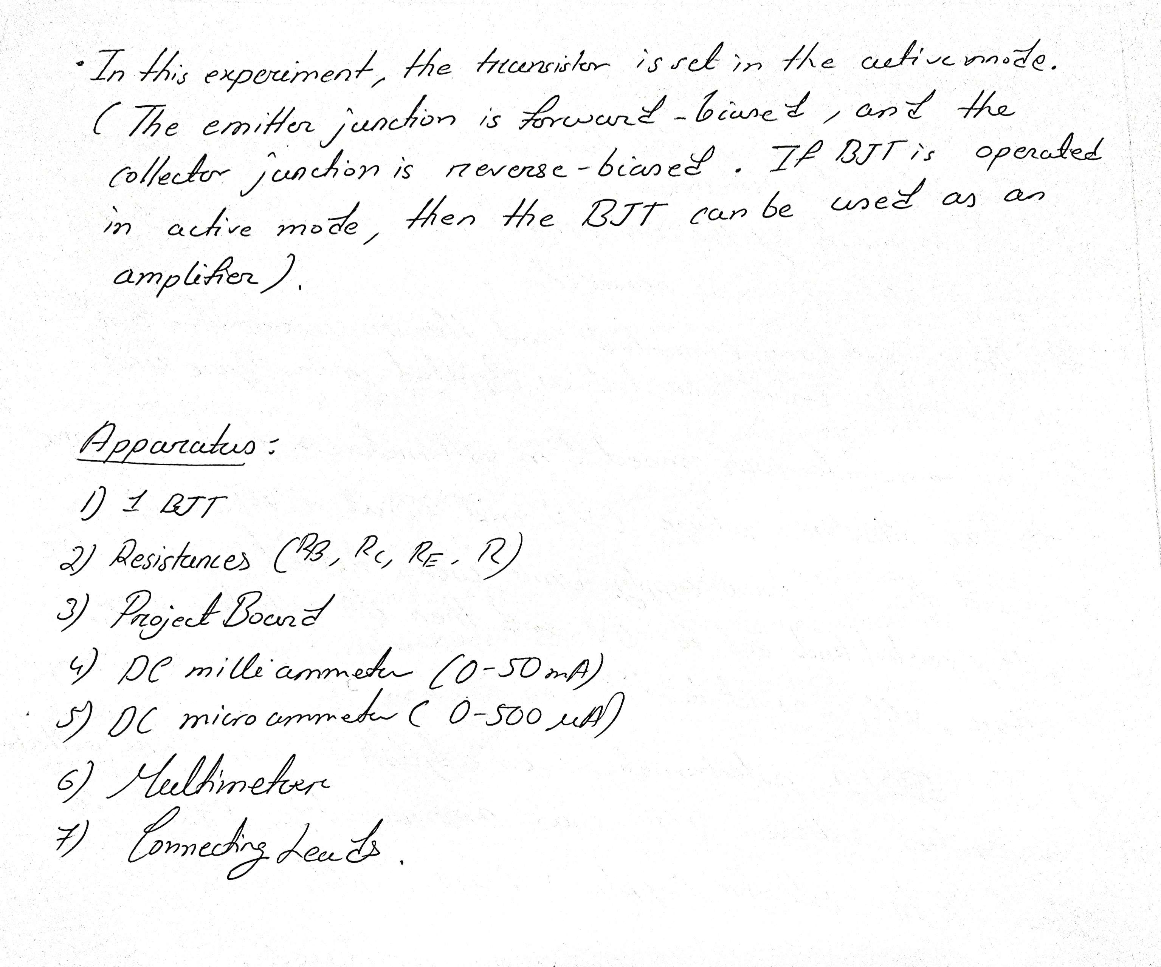

***Apparatus:***



***Figure:***



***Experimental Procedure:*** 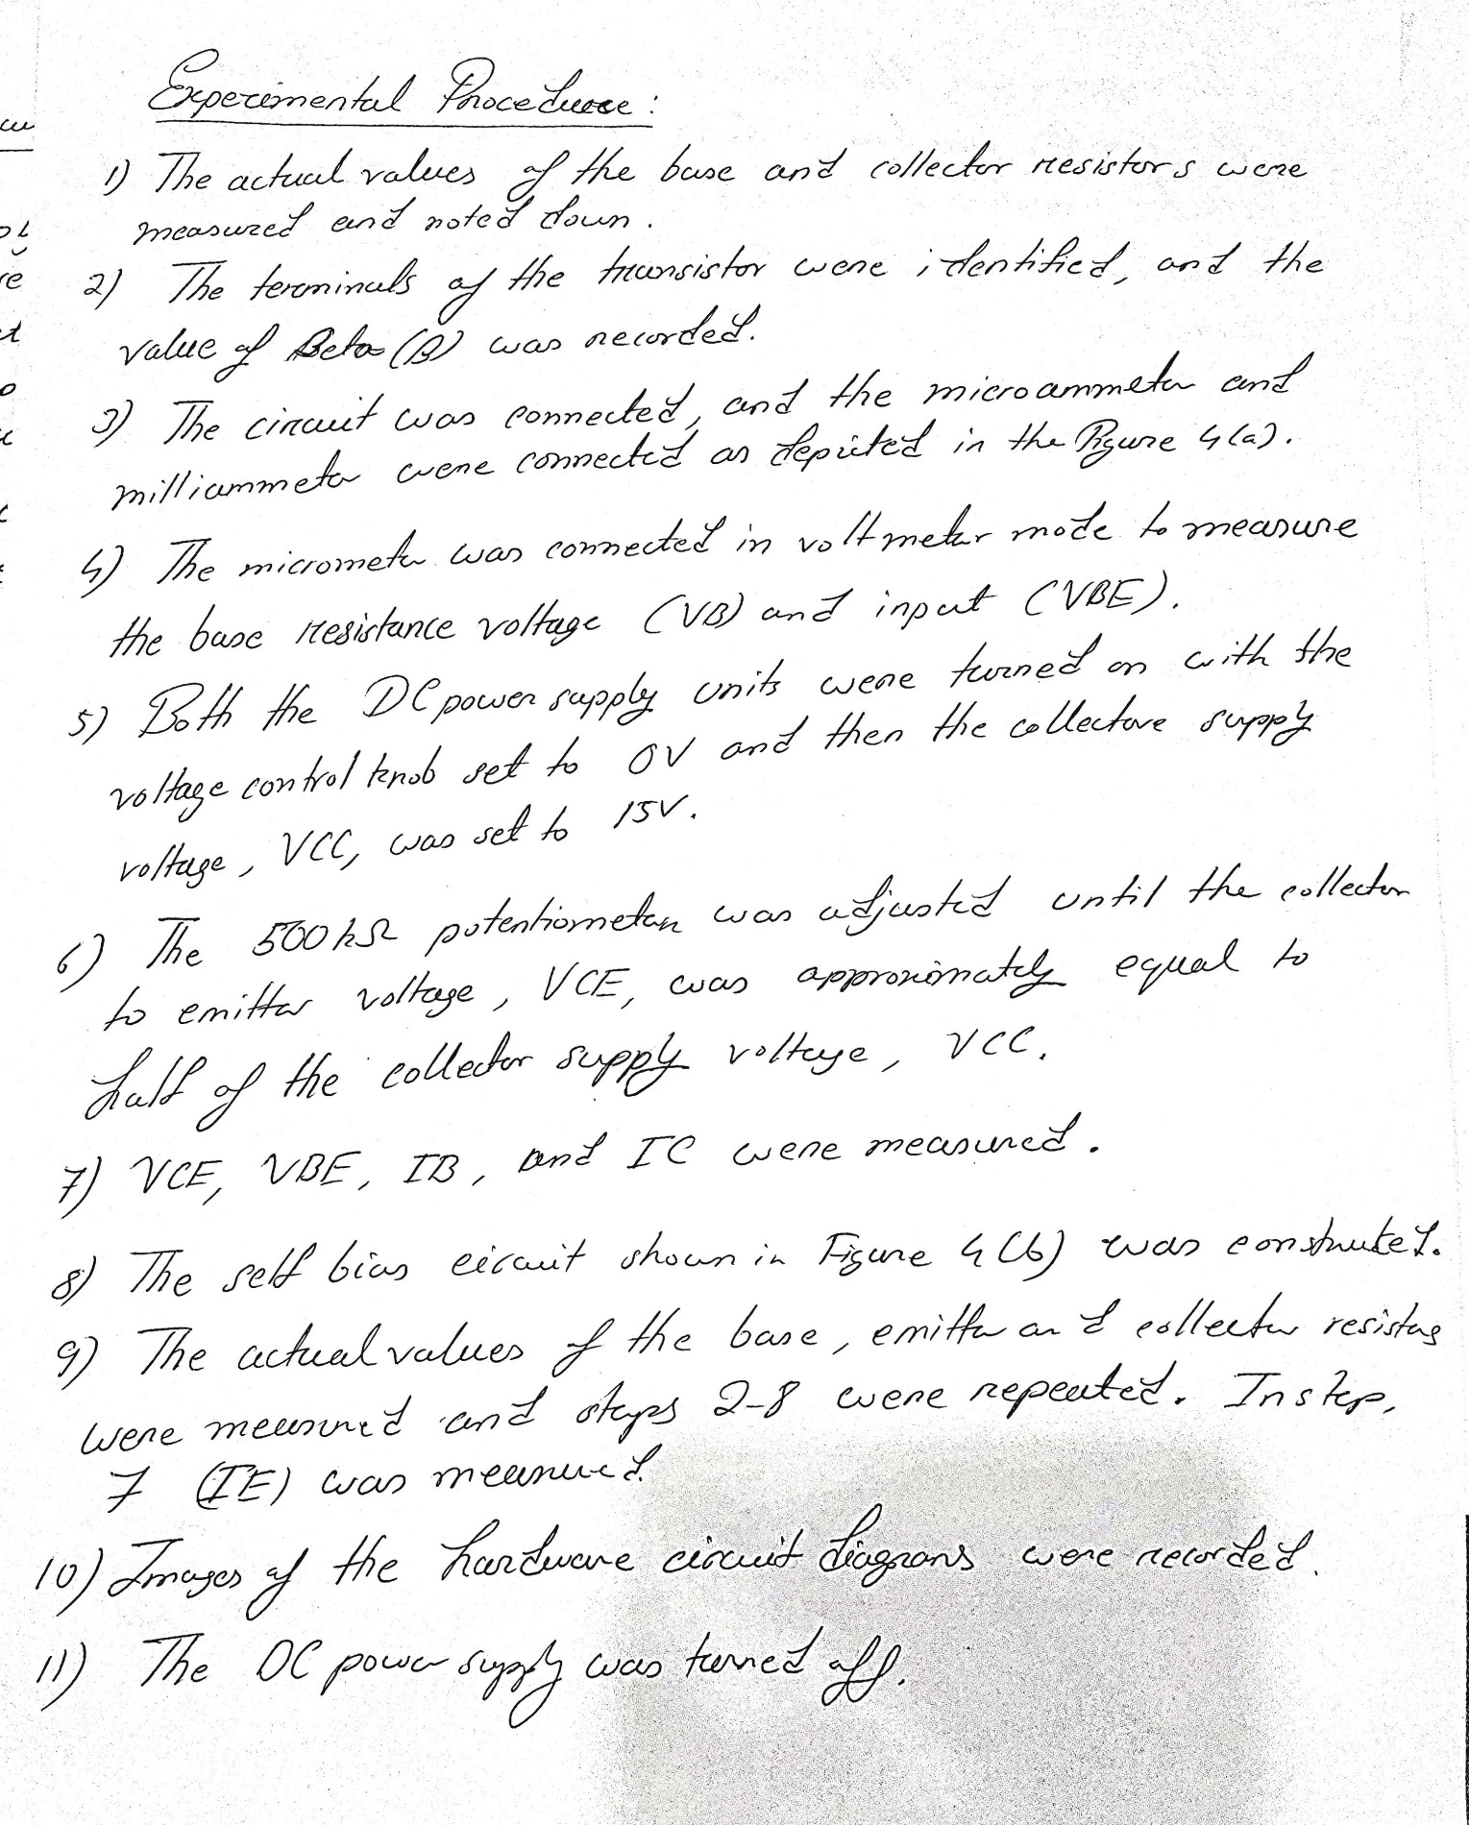

***Results and Simulations:***

*Circuit:*

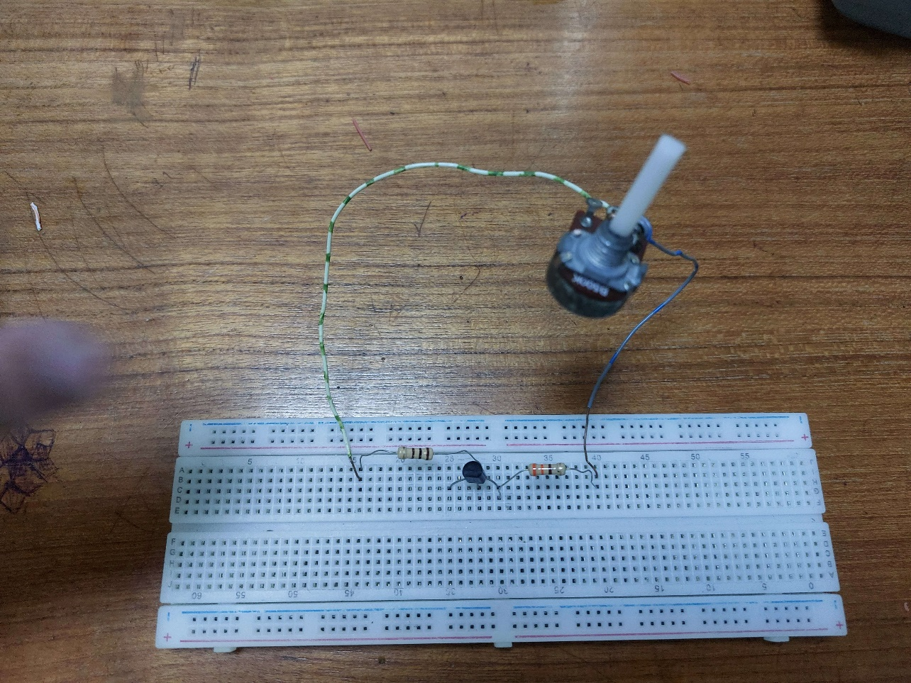

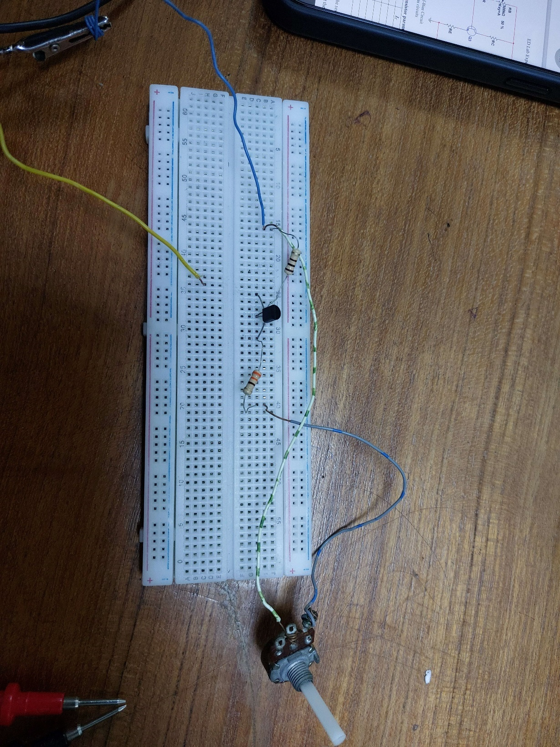

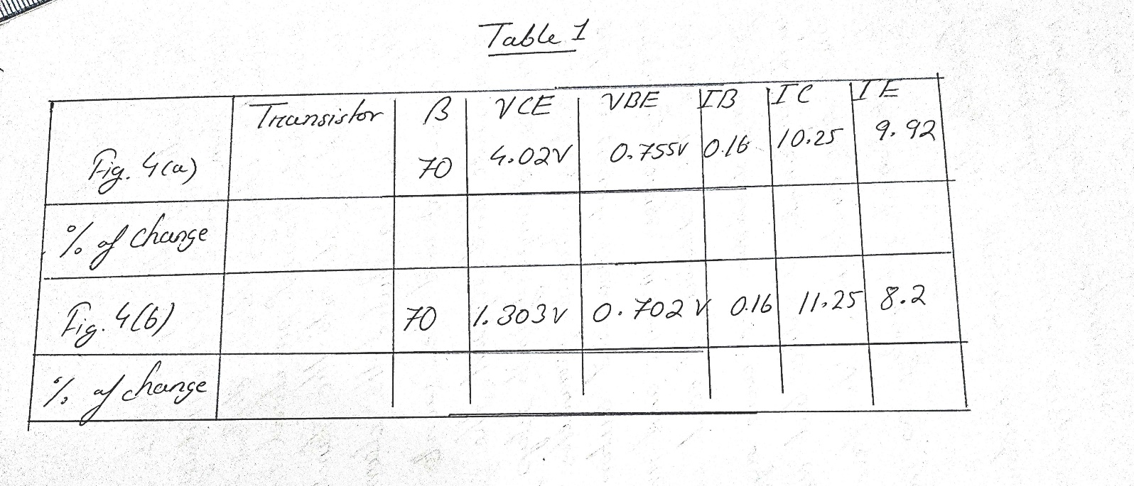*Data Table:*

*Simulation:*

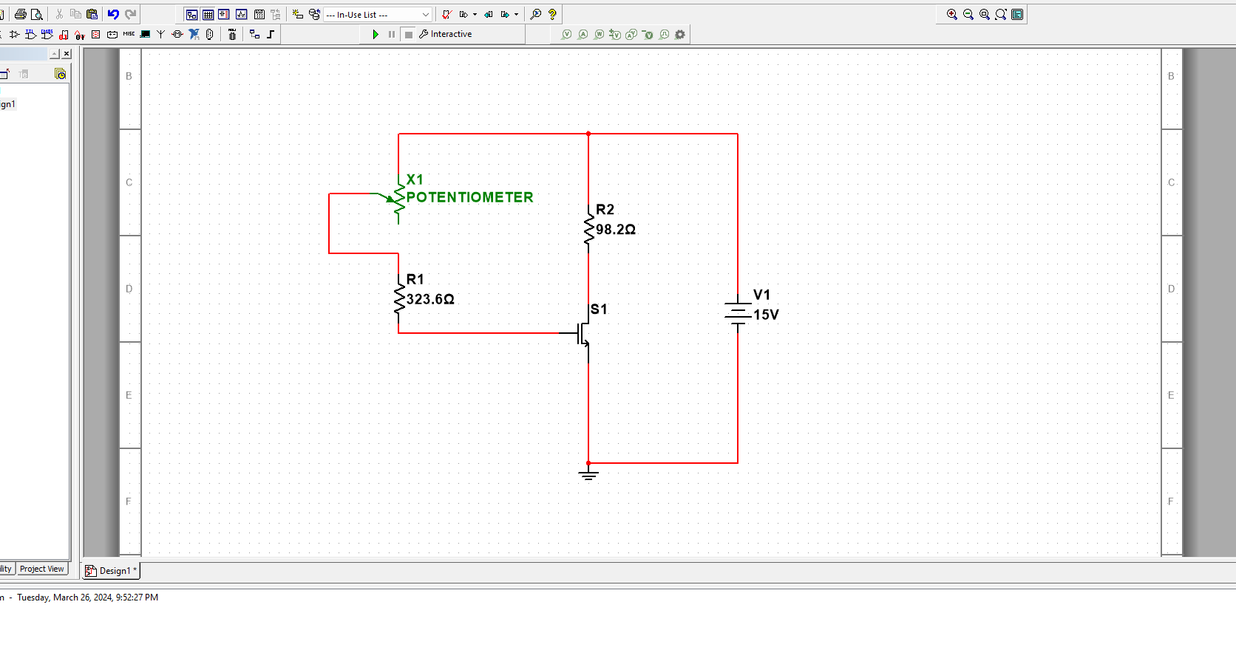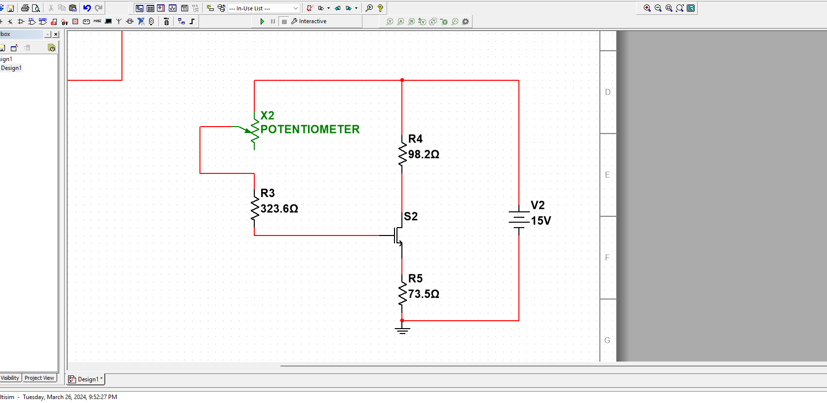

***Discussion and Conclusion:***

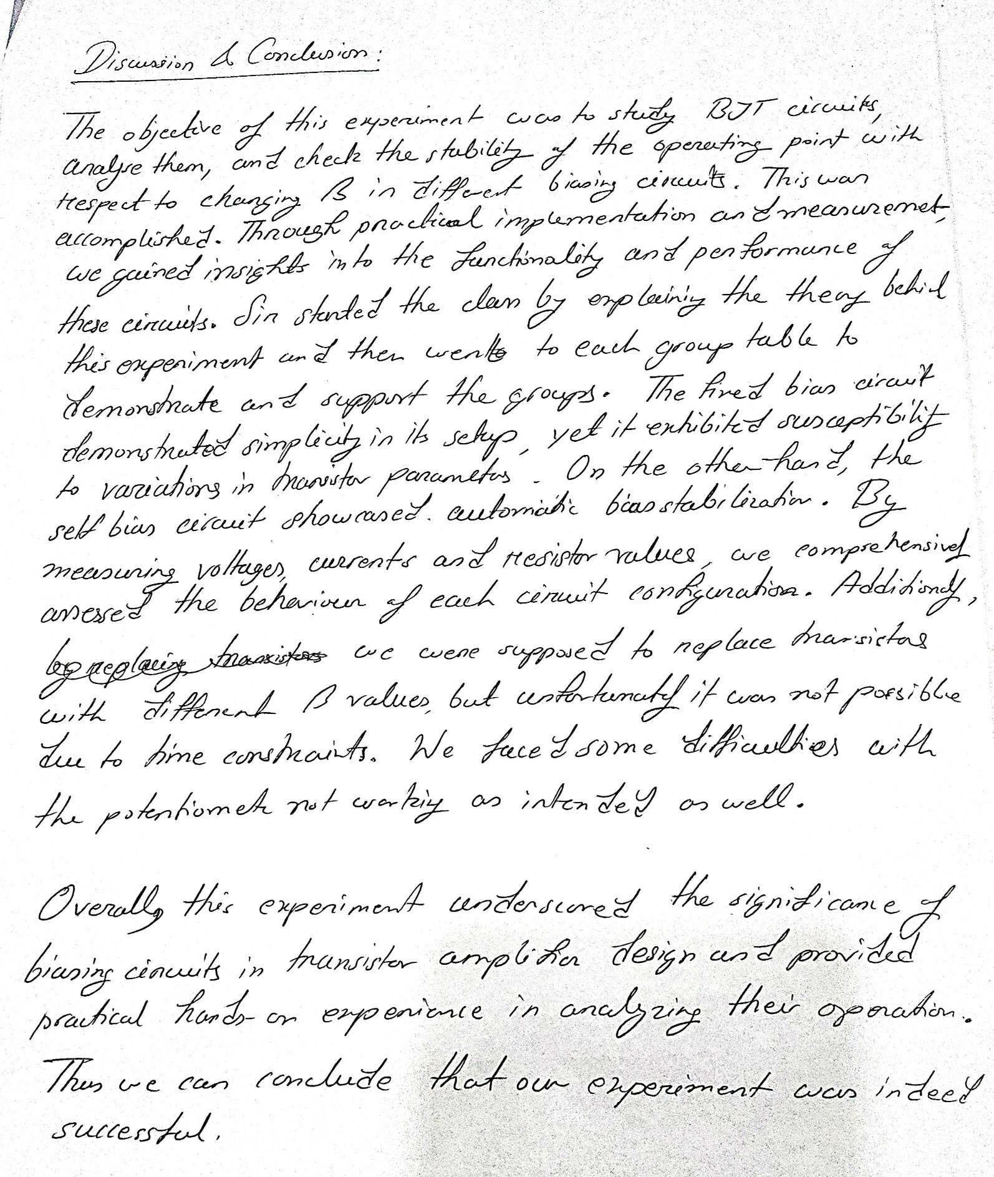

References:

1. Robert L. Boylestad, Louis Nashelsky, Electronic Devices and Circuit Theory, Ninth Edition, 2007-2008

2. Adel S. Sedra, Kennth C. Smith, Microelectronic Circuits, Saunders College Publishing, 3rd ed., ISBN: 0-03-051648-X, 1991.

3. American International University–Bangladesh (AIUB) Electronic Devices Lab Manual.

4. David J. Comer, Donald T. Comer, Fundamentals of Electronic Circuit Design,

john Wiley & Sons Canada, Ltd.; ISBN: 0471410160, 2002.

5. ChatGPT.

6. https://ecstudiosystems.com/discover/textbooks/basic-electronics/bipolar-junction-transistors/types-of-bias/#:~:text=A%20combination%20of%20fixed%20and,type%20shown%20in%20figure%20below.

7. https://www.electronics-tutorials.ws/amplifier/transistor-biasing.html